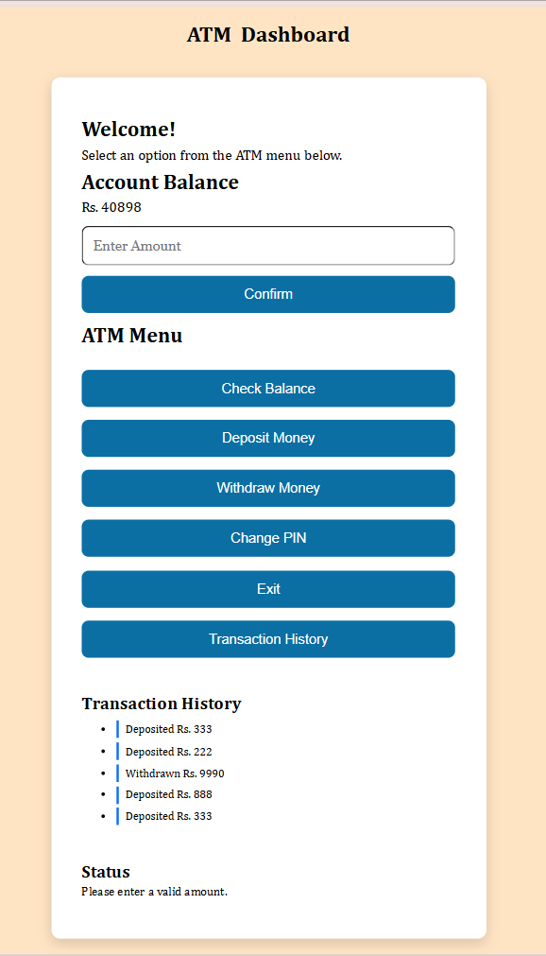

ATM Machine Simulation using HTML, CSS & JavaScript

Project Overview
The ATM Machine Simulation is a front-end web application developed using HTML, CSS, and JavaScript. The project simulates the basic functionality of an Automated Teller Machine, allowing users to perform common banking operations through an interactive interface.
The application consists of two pages:
- Login Page
- ATM Dashboard
The main objective of this project was to strengthen my understanding of JavaScript by implementing real-world programming concepts such as DOM manipulation, event handling, functions, conditional statements, arrays, and Local Storage.

Features Implemented

Login Page
- ATM card insertion
- PIN authentication
- Validation for empty and invalid PIN
- Successful login redirects the user to the dashboard

Dashboard
Users can perform the following operations:
- Check Account Balance
- Deposit Money
- Withdraw Money
- Change ATM PIN
- View Transaction History
- Exit ATM

Technologies Used
- HTML5
- CSS3
- JavaScript (Vanilla JS)
- Browser Local Storage

JavaScript Concepts Used

1. DOM Manipulation
Used document.querySelector() to access HTML elements.
Example:
const balanceAmount = document.querySelector("#balanceAmount");
Purpose:
- Read user input
- Update balance
- Display messages
- Modify page content dynamically

2. Variables
Used variables to store application data.
let balance = 50000;
let correctPin = "1234";
let transactionHistory = [];
Purpose:
- Store account balance
- Store ATM PIN
- Store transaction records

3. Functions
Created separate functions for each ATM operation.
Examples:
- insertCard()
- checkBalance()
- depositMoney()
- withdrawMoney()
- confirmTransaction()
- changePin()
- displayTransactions()
- saveData()
- loadData()
- exitATM()
Benefits:
- Reusable code
- Better organization
- Easier debugging

4. Event Listeners
Used Event Listeners to respond to button clicks.
Example:
checkBalanceBtn.addEventListener("click", checkBalance);
Buttons connected:
- Check Balance
- Deposit
- Withdraw
- Change PIN
- Confirm
- Exit

5. Conditional Statements
Used if...else statements for validation.
Examples:
- Checking PIN
- Validating amount
- Checking sufficient balance
- Preventing invalid inputs
Example:
if (enteredAmount <= balance) {
balance -= enteredAmount;
}
else {
statusText.textContent = "Insufficient Balance";
}

6. Arrays
Used an array to store transaction history.
let transactionHistory = [];
Example:
transactionHistory.push(`Deposited Rs. ${amount}`);

7. Loops
Used forEach() to display all transactions.
Example:
transactionHistory.forEach(function(transaction){
// display transaction
});

8. Local Storage
Used browser Local Storage to save data permanently.
Stored:
- Balance
- PIN
- Transaction History
Saving Data:
localStorage.setItem("balance", balance);
Loading Data:
localStorage.getItem("balance");
Purpose:
Data remains available even after refreshing the page.

9. Template Literals
Used backticks (`) to insert variables into strings.
Example:
balanceAmount.textContent = `Rs. ${balance}`;

10. Number Conversion
Converted input values into numbers.
Example:
let amount = Number(amountInput.value);
Without conversion, values are treated as strings.

11. Form Validation
Implemented input validation to ensure proper user input.
Checks performed:
- Empty input
- Negative amount
- Zero amount
- Invalid PIN
- PIN length
- Insufficient balance

12. Navigation
Redirected users after successful login.
Example:
window.location.href = "dashboard.html";

13. User Feedback
Displayed status messages after every action.
Examples:
- Login Successful
- Invalid PIN
- Money Deposited Successfully
- Please Collect Your Cash
- Insufficient Balance
- PIN Changed Successfully

Project Workflow

Login Page
- User inserts ATM card.
- PIN input becomes enabled.
- User enters PIN.
- PIN is validated.
- On success, user is redirected to the Dashboard.

Dashboard
User can:
- Check balance
- Deposit money
- Withdraw money
- Change PIN
- View transaction history
- Exit the application
Every successful transaction updates:
- Account Balance
- Transaction History
- Local Storage

Challenges Faced
During development, several issues were encountered and resolved:
- Fixing incorrect DOM element selection
- Handling disabled input fields
- Correct use of template literals
- Preventing invalid transactions
- Managing duplicate HTML IDs
- Implementing Local Storage correctly
- Organizing JavaScript into reusable functions
- Improving UI layout using CSS
These challenges helped strengthen debugging skills and improved understanding of JavaScript.

Learning Outcomes
Through this project, I gained practical experience with:
- HTML page structure
- CSS styling and responsive layout
- DOM Manipulation
- JavaScript Functions
- Event Handling
- Conditional Logic
- Arrays
- Loops
- Local Storage
- Form Validation
- Dynamic UI Updates
- Debugging JavaScript
- Building a complete front-end application from scratch

Future Improvements
Possible enhancements include:
- Multiple user accounts
- User registration
- Secure PIN encryption
- Mini Statement generation
- Fund Transfer feature
- Responsive mobile design
- Dark Mode
- Receipt generation
- Date & Time for each transaction
- Account number and card validation

Conclusion
This ATM Machine Simulation project provided hands-on experience in building an interactive web application using HTML, CSS, and JavaScript. It strengthened my understanding of front-end development concepts, improved my problem-solving abilities, and enhanced my confidence in writing structured JavaScript code. The project also demonstrated how browser Local Storage can be used to preserve user data and create a more realistic user experience.

STEP BY STEP WORK FLOW
1.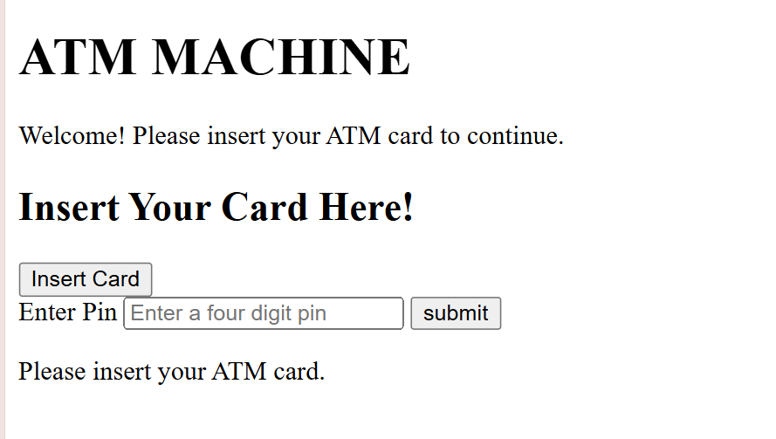
2.
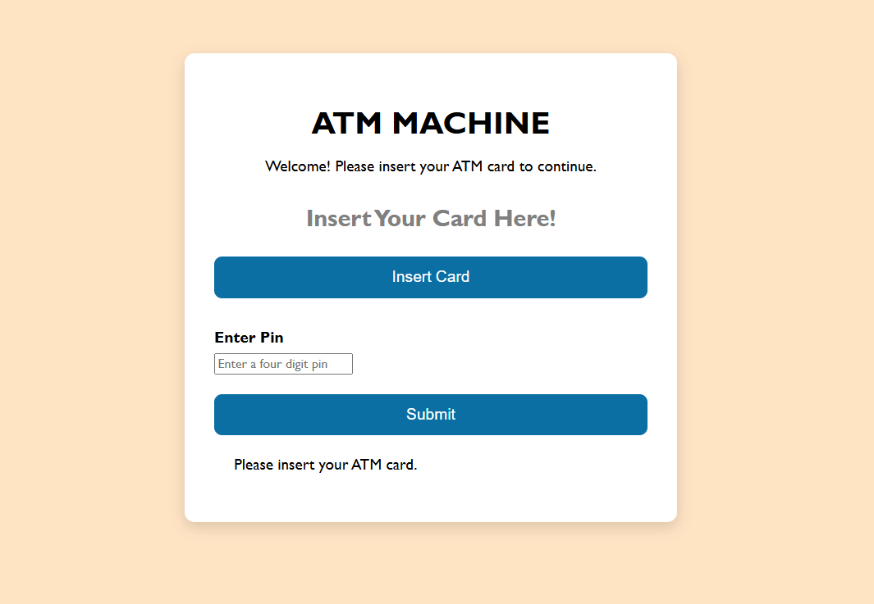
3.
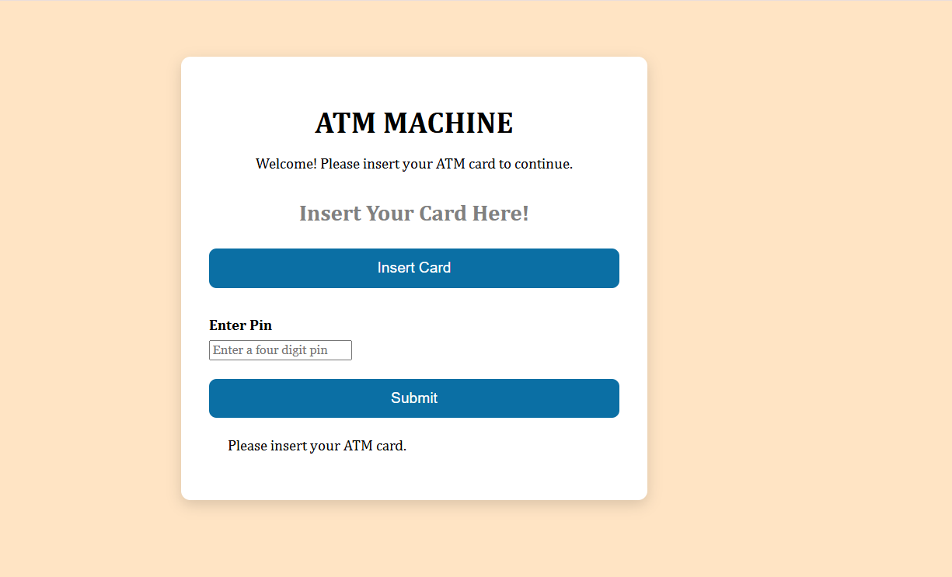
Dashboard View:
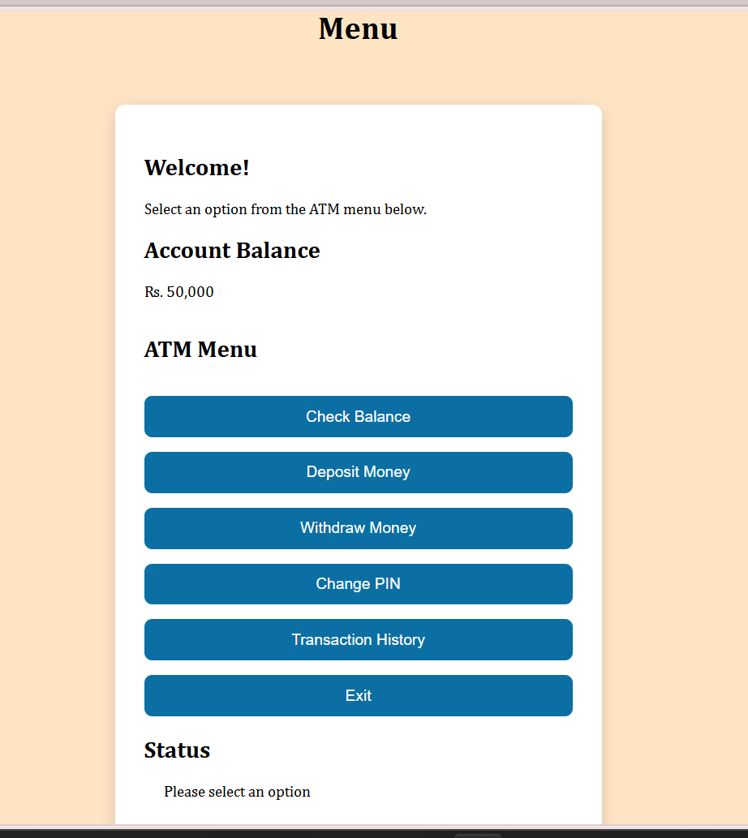
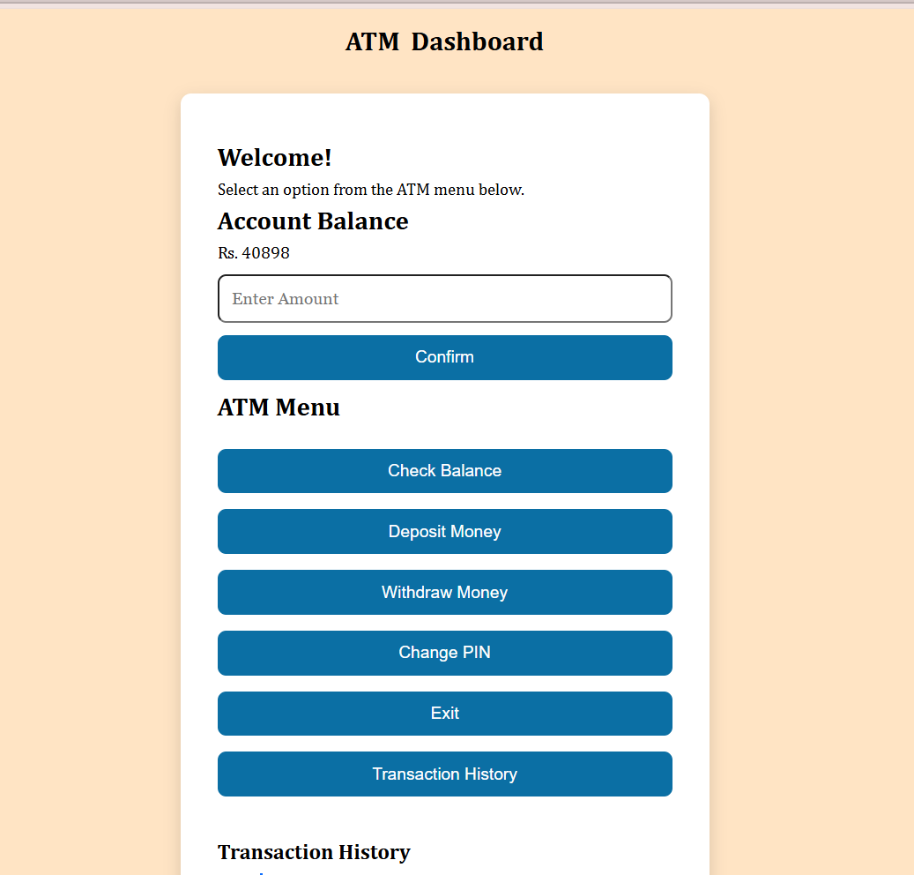
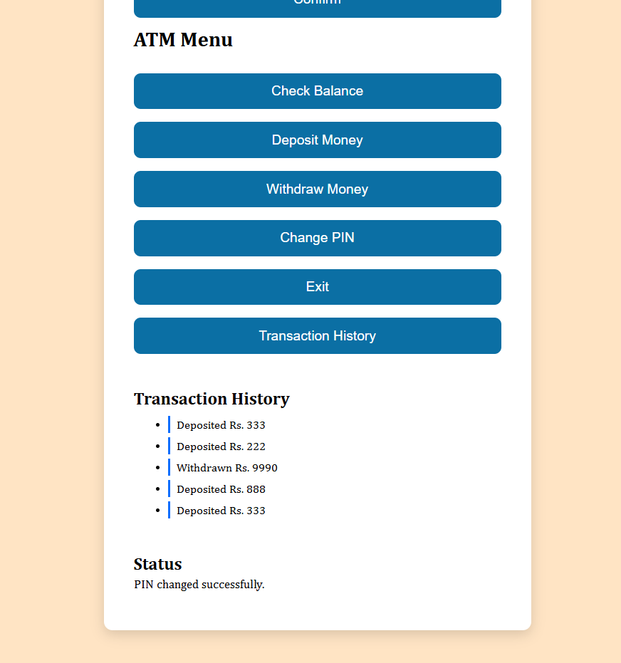
FINAL:


